Bangladesh Medical Association (BMA)
List of Life Member-25
16. BMA Dohar Nawabgonj Branch

Sl No | Voter No | Voter Details
1 | Voter No  LM-1600001  No Image | DR. KHONDKER LIAQUAT ALI  F/Name: Khondker Sanwar Ali  M/Name:  BM & DC Reg. No:  NID:  Cell:  Address: Shamsun Nahar X-Ray Clinic P.O. Nawabgonj, Dhaka.  Blood Group:
2 | Voter No  LM-1600002  No Image | DR. MD. ABU ELIAS PRODHAN  F/Name:  M/Name:  BM & DC Reg. No:  NID:  Cell:  Address:  Blood Group:  TRANSFERED to BMA Dhaka City  LM-1405543
3 | Voter No  LM-1600003  No Image | DR. MD. SAIDUR RAHMAN BHUIYAN  F/Name:  M/Name:  BM & DC Reg. No:  NID:  Cell:  Address:  Blood Group:  TRANSFERED to BMA Dhaka City  LM-1405543
4 | Voter No  LM-1600004  No Image | DR. A.K..M. KABIR  F/Name: M. Iman Ali  M/Name:  BM & DC Reg. No:  NID:  Cell:  Address: Moksedpur Health Sub Centre Dohar, Dhaka.  Blood Group:
5 | Voter No  LM-1600005  No Image | DR. MD. JASIM UDDIN  F/Name: Abdur Rahman  M/Name:  BM & DC Reg. No: 028239  NID:  Cell: 01711016542  Address: EMO UHC Dohar, Dhaka.  Blood Group:
6 | Voter No  LM-1600006 | DR. JOYDEB DAS  F/Name: Haripada Das  M/Name: Lakhirani Das  BM & DC Reg. No: 50800  NID: 19782621809000002  Cell: 01715344620  Address: Rezia Clinic Pvt. Ltd. Joypara, Dohar, Dhaka.  Blood Group: O+
7 | Voter No  LM-1600007  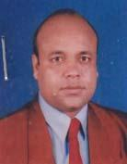 | DR. RAFIQUL ISLAM  F/Name: Fazlur Rahman  M/Name: Rohima Rahman  BM & DC Reg. No: 34005  NID: 2616220566629  Cell: 01819418194  Address: Srestho Seba Clinic, Bandura Bazar, P.O: Hashnabad, Nawabgonj. Dhaka.  Blood Group: O+
8 | Voter No  LM-1600008 | DR. ASHIM KUMAR HALDER  F/Name: Hari Pada Halder  M/Name: Late Yugeshori Halder  BM & DC Reg. No: 45048  NID: 2616220565843  Cell: 01819663569  Address: Vill: New Bandura, Post: Hashnabad, P.S: Nawabgonj, Dhaka: 1321.  Blood Group: B-
9 | Voter No  LM-1600009  No Image | DR. FARZNA AKHTER  F/Name: Sheraj Uddin  M/Name: Late Shahar Banu  BM & DC Reg. No: 50190  NID: 2611852499927  Cell: 01712948090  Address: Vill: Kalalupa, Shamsabad,  Blood Group: n_a
10 | Voter No  LM-1600010 | DR. A. S. K. YEHIA MAHMUD KHAN  F/Name: A. K. M. Murtaza Khan  M/Name: Chowdhury Wahida Khatun  BM & DC Reg. No: 41612  NID: 2694262669659  Cell: 01711352115  Address: Upozilla Health Complex, Dohar, Dhaka.  Blood Group: B+
11 | Voter No  LM-1600011  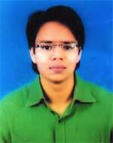 | DR. MD. WAES MARUF RAHMAN  F/Name: Mr. Md. Lutfar Rahman  M/Name: Jahanara Begum  BM & DC Reg. No: 60802  NID: 19888198510364652  Cell: 01819030183  Address: Doctor's Quarter, UHC, Dohar Dhaka  Blood Group: A+
12 | Voter No  LM-1600012 | DR. AJOY KUMAR CHAKRABARTY  F/Name: Late Santosh Chakrabarty  M/Name: Purnima Chakrabarty  BM & DC Reg. No: 38620  NID: 4122303782795  Cell: 01712574182  Address: RMO, Joypara Clinic, Joypara, Dohar, Dhaka  Blood Group: O+
13 | Voter No  LM-1600013 | DR. MOHAMMAD SUMAN SIKDER  F/Name: Mohammad Afzal Hossain Sikder  M/Name: Firoza Begum  BM & DC Reg. No: 38652  NID: 2611842582068  Cell: 01711863436  Address: 1032/A East Monipur, Mirpur-02, Dhaka-1216  Blood Group: B+
14 | Voter No  LM-1600014 | DR. SHYAMLAL PAUL  F/Name: Late Santosh Ch. Paul  M/Name: Late Saraswati Paul  BM & DC Reg. No: 13160  NID: 2616220563118  Cell: 01711706371  Address: Deputy Director, ORS Production and Distribution Cell, Institute of Public Health, Mohakhali, Dhaka  Blood Group: B+
15 | Voter No  LM-1600015 | DR. MD. SHAHIDUL ISLAM  F/Name: Sahmsuddin Mollah  M/Name: Late Fatima Begum  BM & DC Reg. No: 28969  NID: 2698877465993  Cell: 01911567415  Address: Doctors Quarter, UHC, Nawabganj, Dhaka  Blood Group: A+
16 | Voter No  LM-1600016  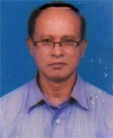 | DR. MOHAMMAD HOSSAIN  F/Name: Late Khorshed Bhuyan  M/Name: Late Shamela Khatun  BM & DC Reg. No: 16066  NID: 2616274339050  Cell: 01812253443  Address: 259/1, Purba Rayer Bazar, Dhaka  Blood Group: A+
17 | Voter No  LM-1600017 | DR. NAZRUL ISLAM MOLLA  F/Name: Noor Mohammad Molla  M/Name: Late Noor Jahan Begum  BM & DC Reg. No: 48380  NID: 2616220558613  Cell: 01818115125  Address: Vill-Puraton Bandura, Post-Hasnabad, P.s-Nawabgonj, Dist-Dhaka  Blood Group: A+
18 | Voter No  LM-1600018 | DR. ABU TAHER  F/Name: Shafiuddin Ahmed  M/Name: Zarina Begum  BM & DC Reg. No: 31379  NID: 2616213410219  Cell: 01819742843  Address: House -125, Road 1/3, Ward-7, Dighirpar, Box Nagar, Nababgonj, Dhaka-1320  Blood Group: O+
19 | Voter No  LM-1600019 | DR. MOHAMMAD DELWAR HOSSAIN  F/Name: Mohammad Mazar Ali  M/Name: Nurjahan Begum  BM & DC Reg. No: 36646  NID: 2699039526409  Cell: 01712585380  Address: RMO, Paragon Hospital and Trauma Center, Nawabgonj, Dhaka  Blood Group: O+
20 | Voter No  LM-1600020 | DR. MEZBAH UDDIN  F/Name: Md. Abdul Jabber  M/Name: Mrs. Sayma Sultana  BM & DC Reg. No: 62847  NID: 19892616213407370  Cell: 01712170448  Address: Vill-Tuknikanda, Post-Boxs Nagar, P.s-Nawabgonj, Dist-Dhaka  Blood Group: B+
21 | Voter No  LM-1600021 | DR, MOHAMMAD IMARAT HOSSAIN  F/Name: Mohammad Abdul Majid  M/Name: Mrs. Firoza Begum  BM & DC Reg. No: 40950  NID: 2616254439801  Cell: 01712188932  Address: Chameli House, 1st Floor, Upazila Health Complex, Dohar, Dhaka  Blood Group: O+
22 | Voter No  LM-1600022 | DR. MOHAMMAD MONIRUZZAMAN BHUIYAN  F/Name: Mohammad Abdul Wahab Bhuiyan  M/Name: Mrs. Sufia Begum  BM & DC Reg. No: 30202  NID: 2695045912197  Cell: 01711583692  Address: Vill-Bagmara, Post & P.s-Nabwabgonj, Dist-Dhaka  Blood Group: O-
23 | Voter No  LM-1600023  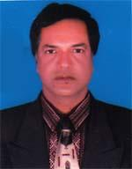 | DR. GANGAGOBINDA PAUL  F/Name: Late Fatick Chandra Paul  M/Name: Late Sonamala Paul  BM & DC Reg. No: 14624  NID: 2616254445711  Cell: 01715937442  Address: AD, CMSD, Tejgaon, Dhaka  Blood Group: B+
24 | Voter No  LM-1600024 | DR. SANCHITA PAUL SHIPLA  F/Name: Dr. Gangagobinda Paul  M/Name: Purabi Rani Paul  BM & DC Reg. No: 54003  NID: 2694066782320  Cell: 01819008443  Address: 51, North Pirerbag, Mirpur-1, Dhaka.  Blood Group: B+
25 | Voter No  LM-1600025  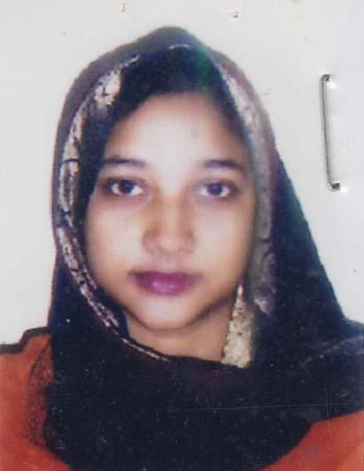 | DR. FAZLE NOOR-E-TAWHIDA  F/Name: Md. Abdul Fattah  M/Name: Husne Ara Begum  BM & DC Reg. No: 32106  NID: 2691648076368  Cell: 01711808696  Address: UHC ,Nawabgonj, Dohar. Dhaka.  Blood Group: O+

